Kính thưa quí bạn
Hôm nay gởi các bạn cái email ngắn vì muốn cho các bạn hay một chuyện
1. Nơi test Virus Vũ Hán free tại Orange County của CalOptima (thấy tờ thông báo thì gởi chớ không liên hệ chi tới tôi đâu nghe bà con)
2. Video Que sera sera (Doris Day hát) hợp cho hoàn cảnh hiện giờ.
3. Giới thiệu kho sách xưa của Quán Ven Đường
4. Những hình ảnh thời Corona xem cho vui
HCD 15-May-2020
--------

Video nhạc Que sera sera (Doris Day)

----------

Tensions are mounting among protesters at the Michigan State Capitol as disagreements about protest messaging pop up. In one particular incident reported by The Detroit News, two protesters fought over a display featuring a doll with a noose around its neck and the American flag. According to pro... View the article. https://flip.it/00tCqa
HCD: Trong link nầy có cái video giành giựt lá cở treo hình nộm
----------
Đây là tờ giấy thông báo, chi về tiết tôi không biết chi hết. Các bạn cần thì hỏi những địa chỉ hay số phone trong đó.
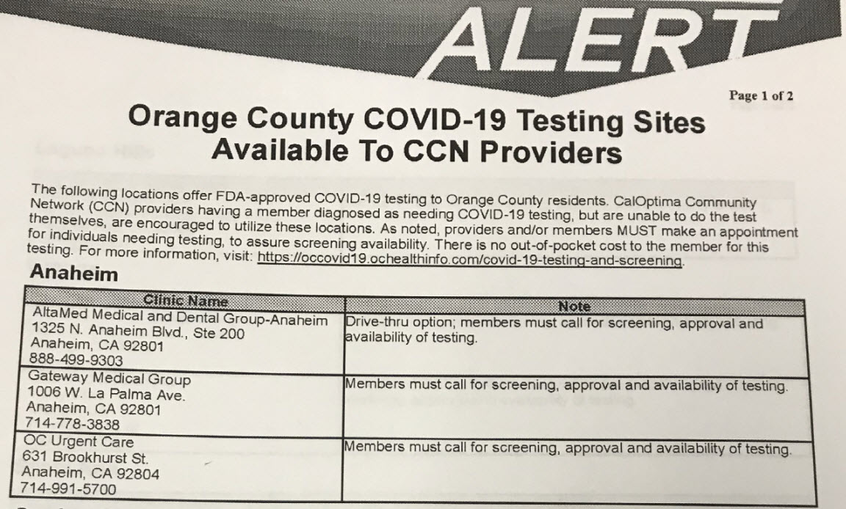

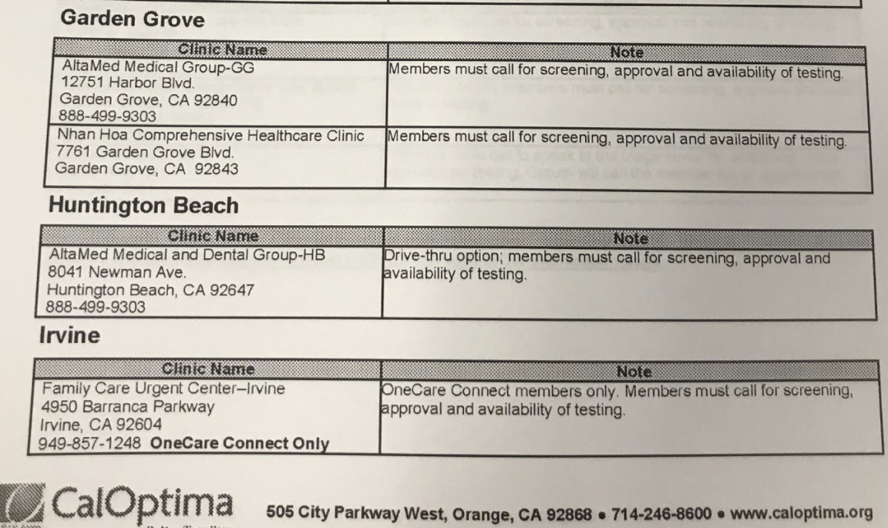
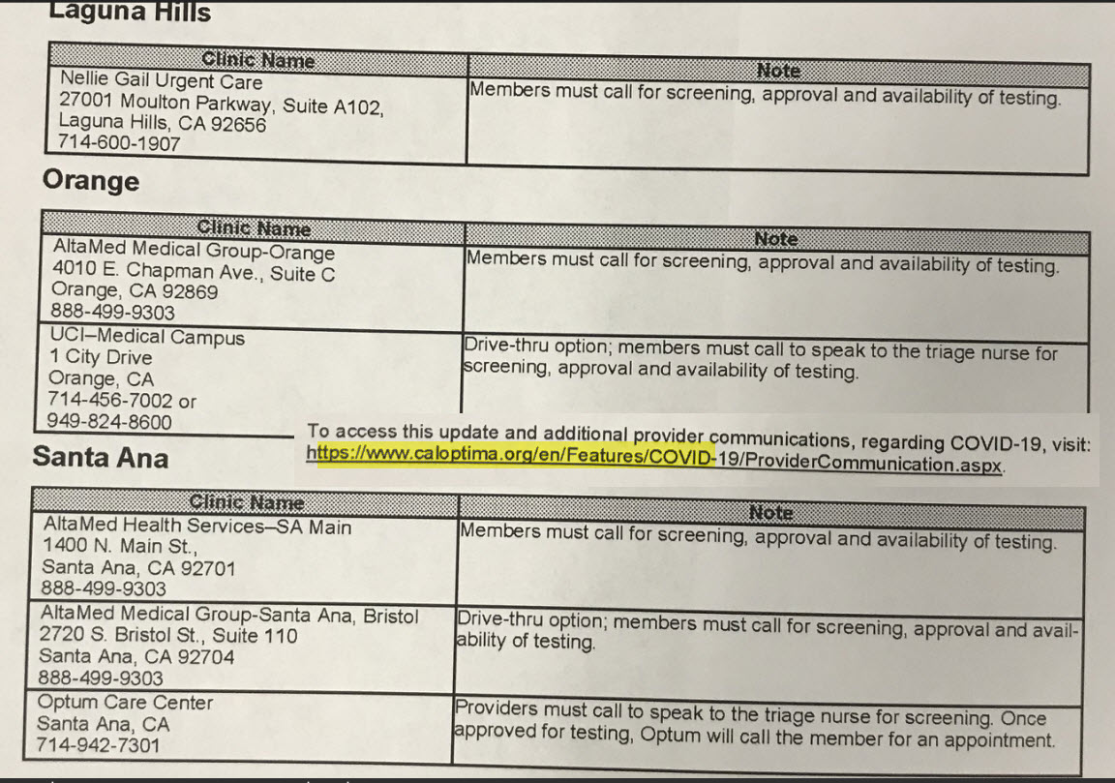
Máy nhận mặt chữ: Các bạn nên đọc từ trong hình, chỗ nào lem nhem các bạn có thể đọc chữ do máy nhận diện dưới đây để dò lại. Tôi không dò lại, chỉ là raw data, chưa edit lại
Orange County COVID-19 Testing Sites Available To CCN Providers
Page 1 of 2
The following locations offer FDA-approved COVID-19 testing to Orange County residents. CalOptima Community twork (CCN) providers having a member diagnosed as needing COVID-19 testing, but are unable to do the test serves, are encouraged to utilize these locations. As noted, providers and/or members MUST make an appointment naviduals needing testing, to assure screening availability. There is no out-of-pocket cost to the member for this testing.
For more information, visit: https://occovid19.ochealthinfo.com/covid-19-testing-and-screening
Anaheim
Group-Anaheim
Clinic Name Altamed Medical and Dental 1325 N. Anaheim Blvd., Ste 200 Anaheim, CA 92801 8884999303 Gateway
Medical Group 1006 W. La Palma Ave.
Anaheim, CA 92801 7147783838 OC Urgent Care 631 Brookhurst St.
Anaheim, CA 92804 714-991-5700
Garden Grove
Clinic Name
Note Drive-thru option; members must call for screening, approval and availability of testing.
Members must call for screening, approval and availability of testing
Members must call for screening, approval and availability of testing
Từ Pixel 3XL
Garden Grove
Nam Altamed Medical Group-GG 12751 Harbor Blvd.
Garden Grove, CA 92840 888-499-9303 Nhan Hoa Comprehensive Healthcare Clinic 7761 Garden Grove Blvd.
Garden Grove, CA 92843
Huntington Beach
Clinic Name Alta Med Medical and Dental Group-HB 8041 Newman Ave.
Huntington Beach, CA 92647 888-499-9303
Irvine
Clinic Name Family Care Urgent Center-Irvine 4950 Barranca Parkway Irvine, CA 92604 949-857-1248 OneCare Connect Only
CalOptima Laguna Hills
NGUSH
(UNITED STATES)
Members
Members
Forward - Backward. Pane
Arrange
Noto must call for screening, approval and availability of testing
must call for screening, approval and availability of testing
Note prive-thru option members must call for screening, approval and availability of testing.
Note OneCare Connect members only. Members must call for screening, approval and availability of testing.
Từ Pixel 3XL
Laguna Hills
Clinic
Nelle Gail Urgent
Name
Care 27001 Moulton Parkway, Suite A102, Laguna Hills, CA 92656 714-800-1907
Orange
Clinic Name Altamed Medical Group-Orange 4010 E Chapman Ave., Suite C Orange, CA 92869 888-499-9303 UCI-Medical Campus 1 City Drive Orange, CA 7144567002 or 949-824-8600
Santa Ana
Name
Clinic Alta Med Health Services-SA Main 1400 N Main St.,
Santa Ana, CA 92701 888-499-9303 Alta Med Medical Group-Santa Ana, Bristol 2720 S. Bristol St., Suite 110 Santa Ana, CA 92704 888-499-9303 Optum Care Center
Santa Ana, CA 714-942-7301
Note
Page 2 of 2
Members must call for screening, approval and availability of testing
Note must call for screening, approval and availability of testing
Members
Drive-thru option, members must call to speak to the triage nurse for screening, approval and availability of testing.
Note Members must calli screening, approval and availability of testing
Drive-thru option; members must call for screening approval and aval- ability of testing
Providers must call to speak to the triage nurse for screening Once
approved for testing Optum will call the member for an appointment
To access this update and additional provider communications, regarding COVID-19, visit:
Từ Pixel 3XL
UC-Medical Campus 1 City Drive Orange, CA 7144567002 or 949-824-8600
Santa Ana
Clinic Name AltaMed Health Services-SA Main 1400 N. Main St.,
Santa Ana, CA 92701 888-499-9303 Alta Med Medical Group-Santa Ana, 2720 S. Bristol St., Suite 110 Santa Ana, CA 92704 888-499-9303 Optum Care Center Santa Ana, CA 714-942-7301
Bristol
Note Members must call for screening, approval and availability of testing.
Drive-thru option; members must call to speak to the triage nurse for
screening, approval and availability of testing
Note
Members must call for screening, approval and availability of testing
Drive-thru option; members must call for screening approval and avail
ability of testing
Providers
must
call to speak to the triage nurse for screening Once approved for testing, Optum will call the member for an appointment
To access this update and additional provider communications, regarding COVID-19, visit:
https://www.caloptima.org/en/Features/COVID-19/ProviderCommunication.aspx
Từ Pixel 3XL
-------------

Kho sách xưa của Quán Ven Đường

Brazilian President Jair Bolsonaro, front row center, wears a protective mask alongside ministers during the National Flag Raising ceremony at Alvorada Palace in Brasilia on May 12.

Commuters use social distancing marker lanes at Gare Montparnasse railway station in Paris on May 12.

Traffic moves over the Golden Gate Bridge in San Francisco, California, on May 12.

People eat lunch behind plastic barriers to enforce social distancing measures at a cafeteria inside the Seoul City Hall on May 11. South Korea

