From: HCD <dhuynh17@socal.rr.com>
To: HCD <dhuynh17@socal.rr.com>
Sent: Tue, May 11, 2010 7:53:47 AM
Subject: FW: chuyen vui buoi sang ngay 11-May-10 va chuyen thuoc men email chuyen computer
Ki'nh Tha^`y,
Xin Tha^`y vui lo`ng chi? cho la`m ca'ch na`o chia mo^.t film ho'n 8Gb la`m hai de^? burn ra tha`nh 2 di~a bi`nh thu'`o'ng (4.7 Gb x 2)
Em xin ca'm o'n Tha^`y
DH Le^~
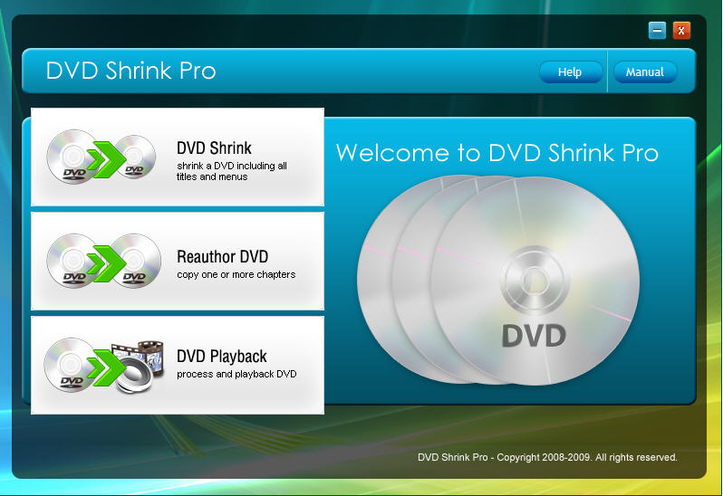
DVD Shrink Pro
Use DVDShrink to backup all your favorite DVDs directly on your hard drive easily and quickly. DVDShrink is a powerful software that works in conjunction with other DVD software to make backups of any DVD. DVDShrink enables you to compress DVDs while preserving existing DVD contents including menus, trailers, and subtitles, or choose to edit or remove those features completely. This software also supports multi-session DVD/CDs.
http://www.mediafire.com/?yzykuonenmn
Last edited by chrischau3; 03-09-2010 at 01:33 AM.

